SECURITY ENHANCEMENTS USING ROUTERS AND SWITCHES

A Project work submitted in partial fulfillment
Of the requirement for the award of the degree

Master of Computer Applications

By

VENKATAMALLIKARJUNARAO KOSURI

(Regd. No. 06471F0002)

Under the esteemed guidance of

Mr. A. CHANDRA SEKHAR MCA, M.Tech.



Department Of Master of Computer Applications
NARASARAOPETA ENGINEERING COLLEGE
NARASARAOPET-522601
(Affiliated to Jawaharlal Nehru Technological University, Kakinada)
2006-2009
NARASARAOPETA ENGINEERING COLLEGE
CERTIFICATE

This is to certify that this project entitled “SECURITY ENHANCEMENTS USING ROUTERS & SWITCHES” is a bonafide work carried out by VENKATAMALLIKARJUNARAO. KOSURI bearing Hall Ticket No: 06471F0002 in during the academic year: 2006-2009. And submitted to Jawaharlal Nehru Technological University in partial fulfillment of the requirements for the award of Master of Computer Applications.

Project Guide Head of the Department
(Mr. A. Chandra Sekhar., M.C.A., M.Tech) (Mr.V.Mahesh Babu M.C.A, M.Tech, (Ph.D))

External Examiner

Acknowledgment

I wish to express our thanks to various personalities who are responsible for the completion of the project. I am extremely thankful to our beloved Chairman Sri. M. V. KoteswaraRao B.sc, who took keen interest in us in every effort throughout this course. I owe my gratitude to our principal Dr. B. V.Rama Mohana Rao M.Tech., Ph.D., for his kind attention and valuable guidance throughout the course.

I express my deep felt gratitude to Mr. V. Mahesh Babu, M.C.A, M.Tech. (Ph.D.), H.O.D. M.C.A Applications department and my guide Mr. A. Chandra Sekhar M.C.A., M.Tech, whose valuable guidance and unstinting encouragement enable me to accomplish my project successfully in time Their profound knowledge and willingness have been a constant source of inspiration for me throughout this project work.

I express my earnest thanks to other faculty members of M.C.A for extending their helping hands and valuable suggestions when need.

Mallikarjunarao. Kosuri

Index

Sl.No | Contents | Page No.
1 | Abstract | 5
2 | Introduction | 7
3 | System Analysis
 | Existing System | 15
 | Proposed System | 18
4 | Software Requirement Specification
 | Software Requirements | 20
 | Hardware Requirements | 20
5 | System Design
 | Hierarchical Network Design | 22
 | IP Subnetting | 25
 | Topology Design | 28
 | Floor Design | 31
 | Connection Layout | 32
6 | Coding & Implementation
 | IPsec Overview & Implementation | 34
 | VLAN Management | 50
 | Router Passwords | 59
 | SSH Configure | 61
 | IP Subnet Calculator | 62
7 | Screen Shots | 64
8 | Testing
 | Test Cases | 73
9 | Scope for Future Enhancements | 74
10 | References | 75

Abstract

This project is aimed to develop a secure network for managing the communication between routers and switches. The secure purpose we need to configure the router and switch IOS, the router and switch IOS contains different secure protocols.

This project also develop the how the network is designed, the design phases consists of hierarchical network design, IP Subnetting, Connections layout, topology design, floor layout of the office. The hierarchical network design like tree formation of the network. The IP Subnetting divide the large IP address into peaces, Connection layout, topology design and floor layout of the office is comes under the physical design of the network. The three design phases have their own features.

The secure technologies are enabled by using different protocols like IPsec, GRE (Generic Routing Encapsulation) tunneling, SSH and Router passwords. The IPsec is a VPN (Virtual Private Network) technology to provide encryption between point to point locations. The VPN Technology is used when ever we connect our network to public network it maintain the authentication, confidentiality, and data integrity. SSH (Secure Shell) the secure shell is used when ever we remotely connected to a network the information is encrypted the difference between telnet and SSH is in telnet the information is plain text and in SSH the data will be encrypted. The router passwords are used to authenticate the whether particular user is login into system or not.

The above secure technologies are simulated by using GNS3 network simulator, and the physical design of the network is done by using the Microsoft Visio it is software available with Microsoft Office.

Introduction
Companies that have multiple offices need a cost-effective, efficient means to exchange data between those offices. Many companies have created intranets or extranets, which enable users at different locations to view, upload, and download information. However, intranets and extranets are only a partial solution to the problem because the sharing of data is limited to what can be posted on the intranet or extranet. Each office must maintain its own database, and users cannot access data stored at other locations. For example, the accounting department at each office must have a separate database, which cannot be shared over an intranet.

Security is also an issue because the one branch must be connected to the Internet, in order to serve multiple locations. To avoid theses type limits we can Wide Area Technologies (WAN), with in the campus we can use Local Area Connection (LAN)
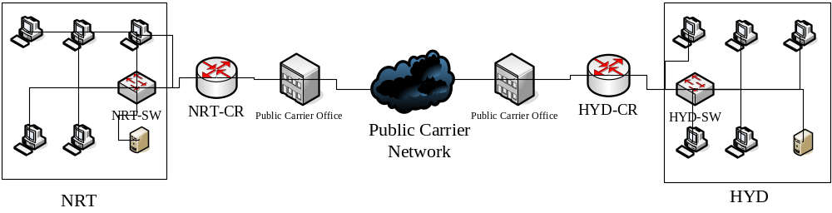

The Routers and Switches are used to implement WAN and LAN technologies, The IOS (internetworking Operating System) used implement secure technologies in routers and switches.

Routers and Switches are the basic building blocks of networking.
Routers are Layer 3 devices and switches are Layer 2 devices.
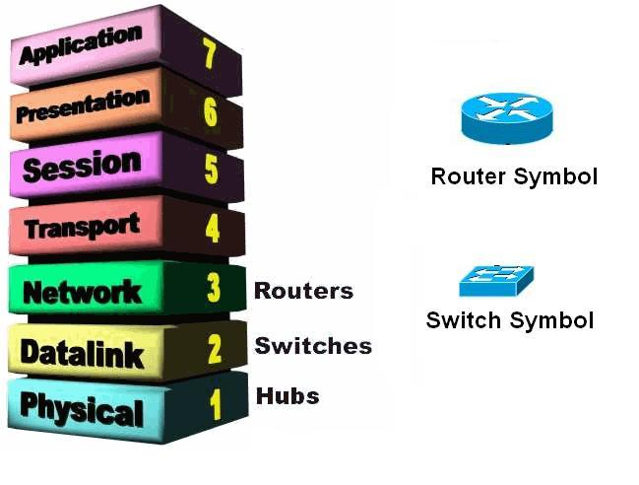

Router
Routers are internetworking devices that operate at the Network Layer (Layer 3) of the OSI model. Using a combination of hardware and software (Cisco Routers use the Cisco IOS—Internet work Operating System), routers are used to connect networks. These networks can be Ethernet, Token Ring, or FDDI—all that is needed to connect these different network architectures is the appropriate interface on the router.
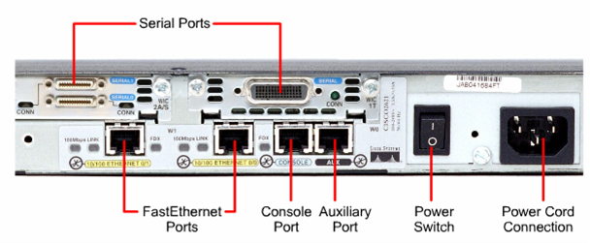

Fig: The Rear View of Cisco 2500 Series router.

Router configuration Sources
- Routers can be configured from:
Console terminal
Auxiliary port – externally, via modems
Virtual terminals (Telnet) – after installation
Downloading from a TFTP server
Internal Configuration Components
- RAM
Contains dynamic / running configuration
- NVRAM
Contains backup of configuration (startup configuration)
- Flash
Contains copy of Cisco IOS
- ROM
Contains a subset of IOS
Contains bootable IOS image
- Interfaces
Network connections which packets enter/exit from routers, e.g. Ethernet, serial, BRI, Token Ring
- Console and auxiliary ports
Main command-line interface used for configuration
Router Startup Sequence -- Summary
- POST
- IOS located in Flash
- IOS expanded and then loaded into RAM
- NVRAM consulted for startup configuration
Router Modes
- User EXEC mode (look, but don’t change)
Automatically enter this mode when router is turned on
You can perform basic tasks, such as connect to remote devices, perform basic tests
Prompt : Router>
- Privileged EXEC mode
High-level testing commands
Set operating parameters
Command to enter :
Router>enable
Prompt : Router#
- Global configuration mode
Commands apply to features that affect the system as a whole
Enter from privileged EXEC mode with command :
Router#config t
Prompt : Router(config)#
- Interface mode
Configure interface, such as Ethernet, serial
Enter from global configuration mode with command :
Router(config)#int e 0/0
Or Router(config)#int s 0/0
Prompt : Router(config-if)#
- Setup mode
Helps new user to create a configuration for the first time, via a series of questions
Prompted at bootup or enter setup at router# prompt
- Rommon mode
Provides router with a small subset of IOS and helps router boot if IOS not found in Flash

Prompt : Rommon 1>

disable
User EXEC

Ctrl-Z
Privileged EXEC

Enable Ctrl-Z
Global configuration

config t
Interface

int e 0/0
int s 0/0

ROUTER STARTUP SEQUENCE
1. POST
2. IOS located in Flash
3. IOS expanded and then loaded into RAM
4. NVRAM consulted for startup configuration

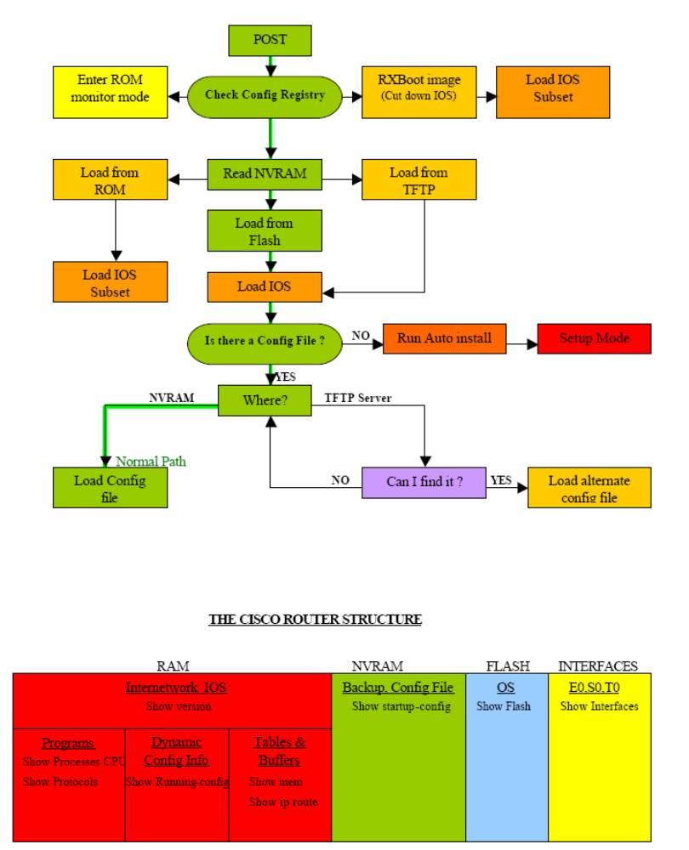
Switch
Switches are Layer 2 internetworking device that can be used to preserve the bandwidth on your network using segmentation. Switches are used to forward packets to a particular segment using MAC hardware addressing (the same as bridges). Because switches are hardware-based, they can actually switch packets faster than a bridge.
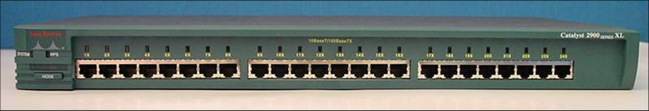
Fig: The rear view of a switch

IOS (Internetworking Operating System)
Cisco's IOS software – an extremely powerful and complex operating system, with an equally complex configuration language. With a cryptic command-line interface and thousands of commands--some of which mean different things in different situations--it doesn't have a reputation for being user-friendly.
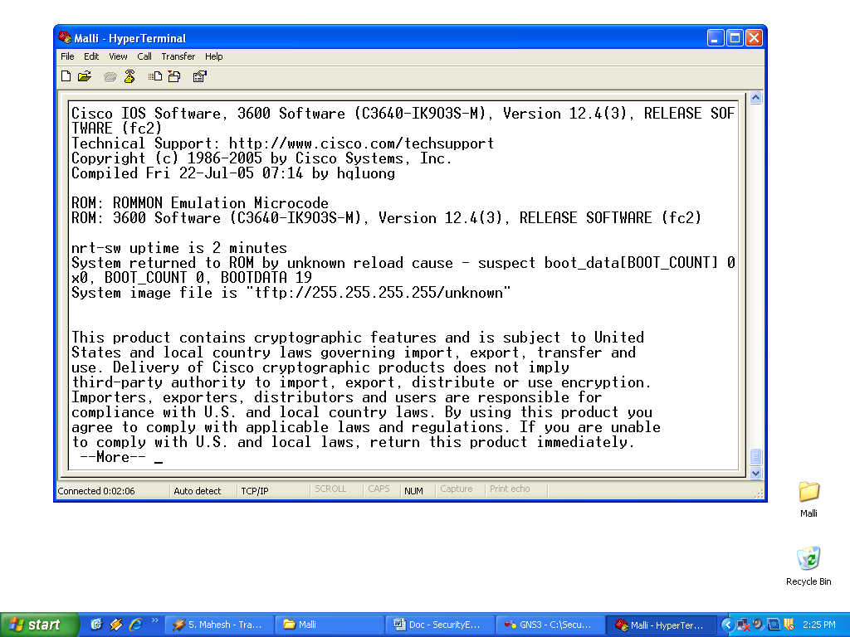

Fig: Cisco IOS software working with console

Advantages using IOS
- It is a Operating system used to manage the routers and switches
- Cisco IOS uses command line interface.
- Reliable and secure access the network and resources.
- Network scalability

System Analysis

Existing System
Today security is the major role in the networking, because the technology is improving day to day enormous so it is necessary to provide security to the network. The attacks are classified into different categories listed below

- Reconnaissance Attacks
- Access Attacks
- Denial of Service Attacks
- Management Protocol Attacks
- Virus, Worms and trogons Attacks

Reconnaissance Attacks
The Reconnaissance Attacks are further divided into
- Packet Sniffers
- Ping Sweeps

Packet Sniffers
Packet Sniffer is a tool by using this we can capture packets in the network, some of the tools area ethereal tool, wire shark etc.
Packets which are send by a network

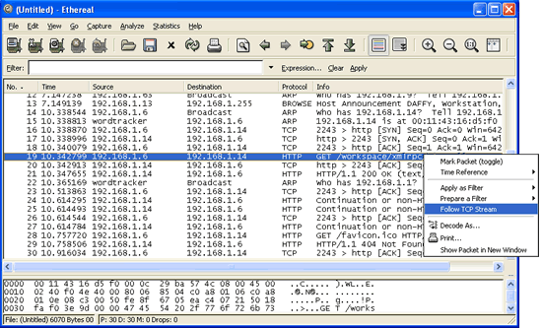
Fig: capturing the packets using ethereal tool
Ping Sweeps
The ping sweeps are used to identify which system is alive in the world
by using the ping command, for this purpose different tools are available in the world some of them are Angry Ping Sweeps

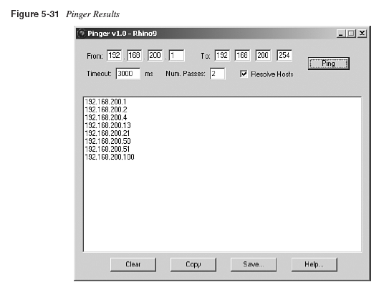

Fig: Angry Sweeps
Access Attacks
The access attacks are further divided into two categories
- Password attacks
- Man-in-the middle attacks
Password Attacks
The password attacks are done by using dictionary based attacks, brute force attacks. By using these techniques they can obtain the passwords in the network.
Man-in-the Middle Attacks
An intruder sits in the middle of the network and hacks the information and modifies the data.

Denial of Services
Denial of Services means in a network restrict particular services in a network, DOS is further divided into 2 type
- IP Spoofing
- Distributed DOS
IP Spoofing
IP Spoofing means creation of IP Packets with forged source IP address
Distributed DOS
The DOS attack is all the devices which are attack already attacked by DOS, the systems are attacked the same server
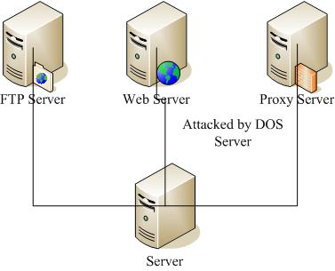

Viruses, Worms and Trogon Horses
The viruses, worms and Trogon horses all are programs they can perform different tasks, they main intention is change the behavior of the system.
Viruses
Virus is a program when it opens it automatically attaches code to another file.
Worms
Worm is a program that replicate without infecting other programs. It is generally slowdown the processor.
Trogons
It is a program that contains code that makes the file unrecognizable
Proposed System
The proposed system is tells how to mitigate the problems in the existing system. The mitigation techniques are listed below according above categories.

Reconnaissance Attacks
The mitigation techniques of reconnaissance attacks are listed below
- Authentication
- Anti Sniffers
- Cryptography
Access Attacks
The mitigation techniques of Access Attacks are listed below
- Eliminate duplicate passwords
- Use strong authentication
- Disable Accounts after failed authentication and cryptography.

DOS
The mitigation techniques of DOS are listed below
- Cryptography
- layered authentication
Viruses, Worms and Trogon horses
The mitigation techniques of viruses, worms and trogon horses are listed below
- Keep up to date ant viruses software.
- Isolated infected devices by using VLANS’ we can isolate the device.
- Industry awareness

Managements Protocol Attacks
The Managements protocol mitigation are listed below
- SSH (Secure Shell)
- cryptography
- VLANS’

Software and Hardware Requirements
Hardware Requirements
Content | Description
Routers | 3 Cisco Routers
Switches | 5 switches Minimum
Simulators | GNS3

Software requirements
Content | Description
OS | Windows XP with SP2
RAM | 1 GB Minimum
Processor | P IV

System Design
The Hierarchical Network Design Model
Network design tends to fallow one of two general design strategies: mesh or hierarchical. In a mesh structure, the network topology is flat; all routers perform essentially the same functions, and there is usually no clear definition of there specific functions are performed. Expansion of the network tends to proceed in a haphazard, arbitrary manner. In a hierarchical structure, the network is organized in layers, each of which has one or more specific functions. Benefits to using a hierarchical model include the following:
- Scalability – Networks that fallow the hierarchical model can grow much layer without sacrificing control or manageability because functionality is localized and potential problems can be recognized more easily. An example of a very large-scale hierarchical network design is the public switched telephone network.
- Ease of implementation – a hierarchical design assign clear functionality to each layer, thereby making network implementation easier.
- Ease of troubleshooting – Because the functions of the individual layers are well defined, the isolation of problems in the network is less complicated. Temporarily segmenting the network to reduce the scope of a problem also is easier.
- Predictability – The behavior of a network using functional layers is fairy predictable, which makes capacity planning for growth considerably easier; this design approach also facilitates modeling of network performance for analytical purposes.
- Protocol support – The mixing of current and future applications and protocols is much easier on networks that follow the principles of hierarchical design because the underlying infrastructure is already logically organized.
- Manageability – All the benefits listed here contribute to greater manageability of the network.

The Three—layer Design Models
A hierarchical network design includes the following three layers:
- The core layer, which provides optimal transport between sites
- The distribution layer, which provides policy-based connectivity
- The access layer, which provides workgroup and user access to the network.
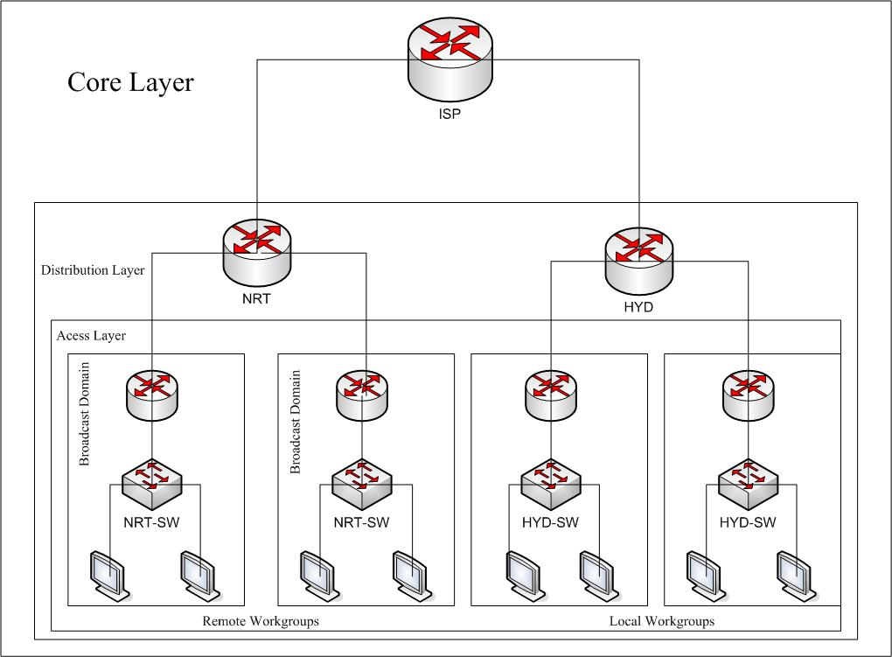

Three-Layer Model Components
A layer is identified as a point in the network where an OSI reference model layer 3 (network layer) boundaries occurs: The three layers are bound by Layer3 devices or other devices that separate the network into broadcast domains. The three-layer model consists of core, distribution, and access layers, each of which has specific functions:
- Core Layer – The core layer provides fast wide-area connections between geographically remote sites, trying a number of campus networks together in a corporate or enterprise WAN. Core links are usually point to point, and there area rarely any hosts in the core layer. Core services typically are leased from a telecom service provider.
- Distribution layer – The distribution layer gives network services to multiple LANs within a WAN environment. This layer is where the campus backbone network is found, and it is typically based on Fast Ethernet. This layer is implemented on large sites and is used to interconnect buildings.
- Access Layer – The access layer is usually a LAN or a group of LANs, typically Ethernet or Token Ring, that provide users with frontline access to network services. The access layer is where almost all hosts are attached to the network, including servers of all kinds and user workstations.

Core Layer functions
- Provides a fast path between remote sites
- Efficient use of bandwidth
- Rapid convergence of routing protocols.

Distribution Layer functions
- Address or area aggregation
- Department or workgroup access to the core layer
- Broadcast/multicast domain definition
- Virtual LAN(VLAN) routing
- Any media transitions that need to occur
- Security

Access Layer Functions
- Shared bandwidth
- Switched bandwidth
- MAC layer filtering
- Micro segmentation

IP Subnetting
The advantages of IP Subnetting is discussed below
- Reduced network traffic – We all appreciate less traffic of any kind networks are no different. Without trusty routers, packet traffic could grind the entire network down to a near standstill. With routers, most traffic will stay on the local network; only packets destined for other networks will pass through the router. Routers create broadcast domains. The smaller broadcast domains you create the less network traffic on that network segment.
- Optimized network performance – This is a result of reduced network traffic.
- Simplified management – It’s easier to identify and isolate network problems in a group of smaller connected networks than within one gigantic network.
- Facilitated spanning of large geographical distances – Because WAN links are considerably slower and more expensive than LAN links, a single large network that spans long distances can create problems in every arena listed above. Connecting multiple smaller networks makes the system more efficient.

How to Create Subnets
To create subnetworks, you take bits from the host portion of the IP address and reserve them to define the subnet address. This means fewer bits for hosts, so the more subnets, the fewer bits available for defining hosts. Before you actually implement subnetting, you need to determine your current requirements as
Well as plan for future conditions. Follow these steps:
- Determine the number of required network IDs:
  - One for each subnet
  - One for each wide area network connection
- Determine the number of required host IDs per subnet:
  - One for each TCP/IP host
  - One for each router interface
- Based on the above requirement, create the following:
  - One subnet mask for your entire network
  - A unique subnet ID for each physical segment
  - A range of host IDs for each subnet
Subnet Masks
For the subnet address scheme to work, every machine on the network must know which part of the host address will be used as the subnet address. This is accomplished by assigning a subnetmask to each machine. A subnet mask is a 32-bit value that allows the recipient of IP packets to distinguish the network ID portion of the IP address from the host ID portion of the IP address.

The network administrator creates a 32-bit subnet mask composed of 1s and 0s. The 1s in the subnet mask represent the positions that refer to the network or subnet addresses.

Not all networks need subnets, meaning they use the default subnet mask. This is basically the same as saying that a network doesn’t have a subnet address. Table 3.1 shows the default subnet masks for Classes A, B, and C. These default masks cannot change. In other words, you can’t make a Class B subnet mask read 255.0.0.0. If you try, the host will read that address as invalid and usually won’t even let you type it in. For a Class A network, you can’t change the first byte in a subnet mask; it must read 255.0.0.0 at a minimum. Similarly, you cannot assign 255.255.255.255, as this is all 1s—a broadcast address. A Class B address must start with 255.255.0.0, and a Class C has to start with 255.255.255.0.

IP Addressing Scheme

VLAN100
- Subnet mask is 255.255.255.192 or /26
- 192.168.1.65 to 192.168.126 is valid host range
- 192.168.1.64 is the network address
- 192.168.1.127 is the broadcast address

VLAN200
- Subnet mask is 255.255.255.192 or /26
- 192.168.1.129 to 192.168.1.190 is valid host range
- 192.168.1.128 is the network address
- 192.168.1.191 is the broadcast address

VLAN300
- Subnet mask is 255.255.255.224 or /27
- 192.168.1.194 to 192.168.1.222 is valid host range
- 192.168.1.192 is the network address
- 192.168.1.223 is the broadcast address

VLAN400
- Subnet mask 255.255.255.248 or /29
- 192.168.1.225 to 192.168.1.230 is valid host range
- 192.168.1.224 is network address
- 192.168.1.231 is broadcast address

VLAN500
- Subnet mask 255.255.255.248 or /29
- 192.168.1.233 to 192.168.1.238 is valid host range
- 192.168.1.232 is network address
- 192.168.1.239 is broadcast address
VLAN600
- Subnet mask 255.255.255.248 or /29
- 192.168.1.241 to 192.168.1.246 is valid host range
- 192.168.1.240 is network address
- 192.168.1.247 is broadcast address
Topology Design

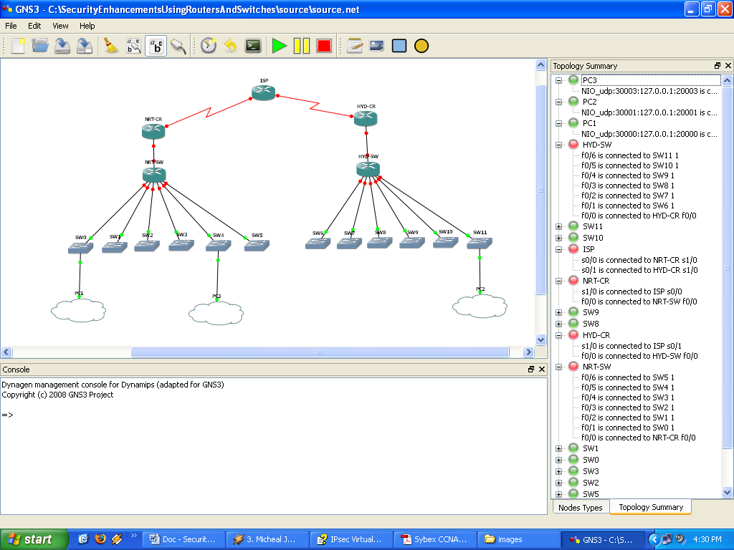

Topology Summary

ISP
- ISP serial interface s1/0 is connected to NRT-CR serial interface s1/0.
- ISP serial interface s0/1 is connected to HYD-CR serial interface.

NRT-CR
- NRT-CR router serial interface s1/0 is connected to ISP s0/0
- NRT-CR Fast Ethernet f0/0 is connected to NRT-SW switch connected to Fast Ethernet f0/0

HYD-CR

- HYD-CR router serial interface serial interface s1/0 is connected ISP serial interface s0/1
- HYD-CR Fast Ethernet f0/0 is connected to HYD-SW switch’s Fast Ethernet f0/0

NRT-SW
- NRT-SW Fast Ethernet f0/0 is connected to NRT-CR Fast Ethernet f0/0
- NRT-SW Fast Ethernet f0/1 is connected to SW0 port 1
- NRT-SW Fast Ethernet f0/2 is connected to SW1 port 1
- NRT-SW Fast Ethernet f0/3 is connected to SW2 port 1
- NRT-SW Fast Ethernet f0/4 is connected to SW3 port 1
- NRT-SW Fast Ethernet f0/5 is connected to SW4 port 1
- NRT-SW Fast Ethernet f0/6 is connected to SW5 port 1

HYD-SW
- HYD-SW Fast Ethernet f0/0 is connected to NRT-CR Fast Ethernet f0/0
- HYD-SW Fast Ethernet f0/1 is connected to SW0 port 1
- HYD-SW Fast Ethernet f0/2 is connected to SW1 port 1
- HYD-SW Fast Ethernet f0/3 is connected to SW2 port 1
- HYD-SW Fast Ethernet f0/4 is connected to SW3 port 1
- HYD-SW Fast Ethernet f0/5 is connected to SW4 port 1
- HYD-SW Fast Ethernet f0/6 is connected to SW5 port 1

SW0
- Port 1 connected NRT-SW f0/1
- Port 2 connected to PC! NIO_udp:30000:127.0.0.1:20000

SW4
- Port 1 connected NRT-SW f0/5
- Port 2 connected to PC3 NIO_udp:30003:127.0.0.1:20003

SW11
- Port 1 connected HYD-SW f0/6
- Port 2 connected to PC2 NIO_udp:30001:127.0.0.1:20001
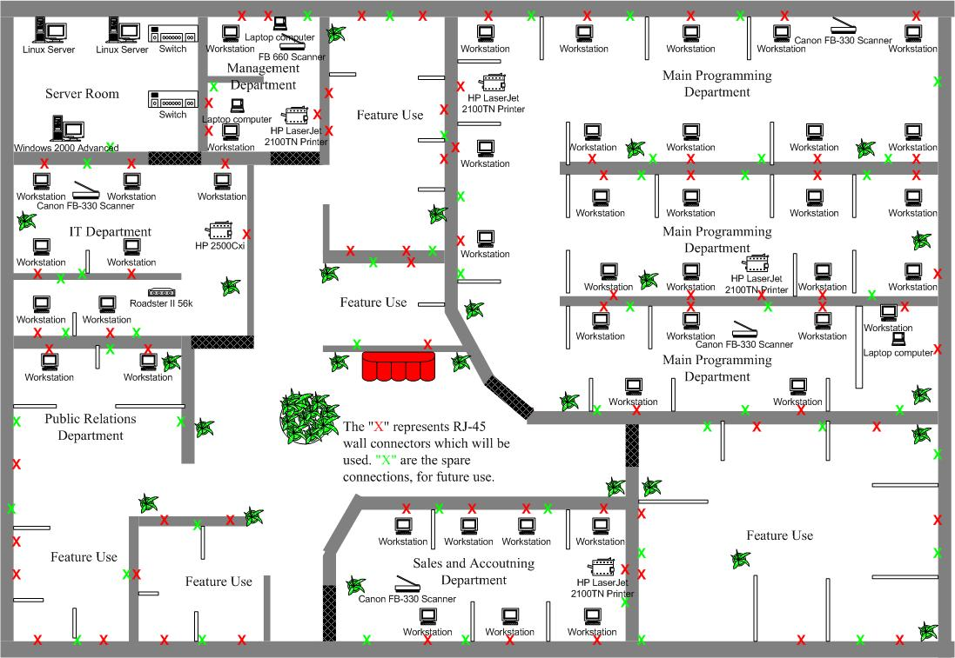
Floor Layout
Connections Layout

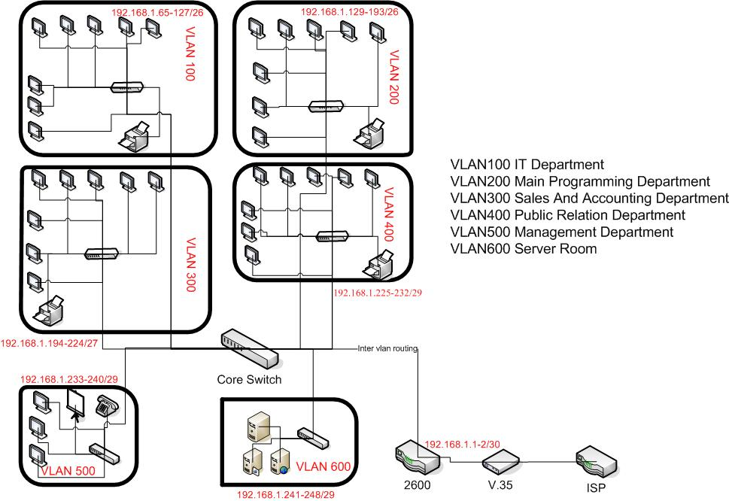

Coding
&
Implementation
IPsec
The IPsec initiative has been proposed to offer a standard way of establishing authentication and encryption services between endpoints. This means not only standard algorithms and transforms, but also standard key negotiation and management mechanisms to promote interoperability between devices by allowing for the negotiation of services between these devices. The Internet Key Exchange (IKE), based on ISAKMP/Oakley, (Internet Security Association Key Management Protocol) is the protocol used to manage the generation and handling of keys. It is also the protocol by which potential peer devices form Security Associations.

A Security Association (SA) is a negotiated policy or agreed way of handling the data that will be exchanged between two peer devices, an example of a policy item is the transform used to encrypt data. The active SA parameters are stored in the Security Association Database (SAD). SAs for both IKE and IPsec are negotiated by IKE over various phases and modes:

• Phase 1: IKE negotiates IPsec SAs during this phase.
Two modes can be used for phase 1:
- Main mode is used in the vast majority of situations.
- Aggressive mode is used under rare circumstances, given particular configuration parameters between two systems.
The user has no control over which mode is chosen. The router automatically chooses a mode, depending on the configuration parameters set up on both peers.

• Phase 2: IKE negotiates IPsec SAs during this phase. The only phase 2 exchange is quick mode.

IPsec SAs terminate through deletion or by timing out. When the SAs terminate, the keys are also discarded. When subsequent IPsec SAs are needed for a flow, IKE performs a new phase 2 and, if necessary, a new phase 1 negotiation. A successful negotiation results in new SAs and new keys. New SAs can be established before the existing SAs expire, so that a given flow can continue uninterrupted.

IPsec in Detail
Within the TCP/IP environment, IPsec protocols offer security services at the IP layer. These security services include access control, connectionless integrity, data origin authentication, protection against replay, confidentiality (encryption), and limited traffic-flow confidentiality.

These security services are provided by the Authentication Header (AH) and the Encapsulating Security Payload (ESP) protocols. Each protocol provides certain services and may be used separately or together, although it is not usually necessary to use both protocols together. Refer to Security Architecture for IP, RFC 2401

The following services are provided by AH and ESP:

- Access control prevents unauthorized use of a resource such as the network behind a security gateway. (A security gateway is an intermediate system such as a router or firewall that interfaces two networks and provides security services for the hosts on the internal side.)
- Connectionless integrity detects any modification to data within individual IP packets, regardless of their position in a data stream.
- Data origin authentication verifies the source of the data. Connectionless integrity and data origin authentication are joint services, and together they are generally referred to as authentication.
- Protection against replay is optional and is a service selected by the receiver. The sender must increment the sequence number used for anti-replay; the receiver can then detect the arrival of duplicate IP packets within a constrained window by checking the sequence number.
- Confidentiality protects data from unauthorized disclosure by using encryption. Confidentiality may be selected independent of any other services. Limited traffic-flow confidentiality occurs by hiding the original source and destination addresses as part of the data when using ESP in tunnel mode. It is most effective if implemented at a security gateway, where traffic aggregation may be able to mask the true source destination patterns. Because both AH and ESP provide access control, the real decision to make when choosing security services is whether you need authentication or both authentication and encryption.

Authentication Header
AH mode provides authentication for as much of the IP header as possible, as well as for all the upper-layer protocols of an IP datagram (for example, ESP, UDP, TCP, ICMP, and Internet Group Management Protocol [IGMP]). However, some of the IP header fields may change in transit and the value of these fields, when the packet arrives at the receiver, may not be predictable by the sender. The values of such fields cannot be protected by AH.

The AH integrity check value (ICV), usually a keyed hash using a shared secret value, is computed over:
- IP header fields that are either immutable in transit or that are predictable in value upon arrival at the endpoint for the AH SA
- The AH, next header, payload len, reserved, SPI, sequence number, the authentication data (which is set to zero for this computation), and explicit padding bytes (if any)
- The upper-layer protocol data, which is assumed to be immutable in transit
The following are immutable fields and are included in the AH ICV computation:
- Version
- Internet header length
- Total length
- Identification
- Protocol (this should be the value for AH)
- Source address
- Destination address (without loose or strict source routing)
The mutable but predictable field is destination address (with loose or strict source routing).
The following are mutable fields (zeroed prior to ICV calculation) and are not included in the computation of the AH ICV:
- Type of service (ToS)
- Flags
- Fragment offset
- Time to Live (TTL)
- Header checksum

The ToS field is excluded because some routers are known to change the value of this field, even though the IP specification does not consider ToS to be a mutable header field. The flags field is excluded because an intermediate router might set the don’t fragment (DF) bit, even if the source did not select it. Because AH is applied only to non-fragmented IP packets, the fragment offset field must always be zero, and thus is excluded (although it is predictable). TTL is changed en route as a normal course of processing by routers. Therefore, its value at the receiver is not predictable by the sender. Header checksum will change if any of these other fields change, so its value upon reception cannot be predicted by the sender.

Encapsulating Security Payload
ESP performs encryption at the IP packet layer. It supports a variety of symmetric encryption algorithms. The default algorithm for IPsec is the 56-bit Data Encryption Standard using the cipher block chaining mode transform (DES-CBC).This cipher must be implemented to guarantee interoperability among IPsec products.

ESP has an optional field for authentication. It contains an ICV that is computed over the remaining part of the ESP less the authentication field itself. The length of the field varies with the authentication algorithm selected. If authentication is not chosen, the ICV is omitted. Authentication is calculated after the encryption is done. The current IPsec standard specifies HMAC (a symmetric signature scheme) with Security Hash Algorithm 1 (SHA1) and Message Digest 5 (MD5) as mandatory implementations.

The Modes of AH and ESP
The format of the AH and ESP headers, and the values contained therein, will vary according to the mode in which they are applied.

Transport Mode
Transport mode is used when both communicating peers are hosts. It may also be applied when one peer is a host and the other is a gateway, if that gateway is acting as a host (for example, a router sending SNMP traffic to an SNMP manager).

Transport mode has an advantage of adding only a few bytes to the header of each packet. With this choice, the original header is not protected. This setup allows the true source and destination addresses to be seen by intermediate devices. One advantage of not changing the original header is that Quality of Service (QoS), for example, can be processed from the information in the IP header. One disadvantage is that it is possible to do traffic analysis on the packets. Remember, transport mode can be used only if the two end devices are the ones providing IPsec protection. Transport mode cannot be used if an intermediate device, such as a router or firewall, is providing the IPsec protection.
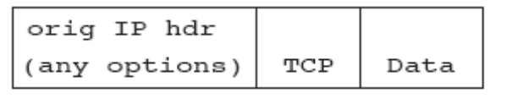

Fig: Original IPv4 packet
Authentication Header
AH services protect the external IP header along with the data payload (see Figure 1-2). It protects all the fields in the header that do not change in transport. The header goes after the IP header and before the ESP header, if present, and other higher-layer protocols.

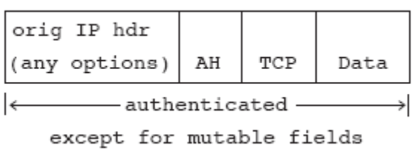

Fig: IP Packet after applying AH in Transport Mode
Encapsulating Security Payload
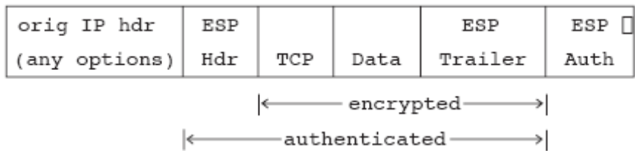
In transport mode, the IP payload is encrypted and the original headers are left intact. The ESP headers are inserted after the IP header and before the upper-layer protocol header (see Figure). The upper-layer protocols are encrypted and authenticated along with the ESP header. ESP does not authenticate the IP header itself. This authentication is important only for IPv6 because there are no known attacks that would require an IPv4 header to be authenticated. Please note that higher-layer information, such as port numbers in the layer 4 header, are not available because they are part of the encrypted payload.

Fig: IP Packet after applying ESP in Transport Mode
Tunnel Mode
Tunnel mode is used between two gateway devices or between a host and a gateway if that gateway is the conduit to the actual source or destination. In tunnel mode, the entire original IP packet is encrypted and becomes the payload of a new IP packet. The new IP header has the destination address of its IPsec peer. This setup allows for tunneling of IP from a protected host (that is not doing IPsec itself) through a router or firewall usually to another router or firewall, both acting as security gateways. One of the advantages of tunnel mode is that intermediate devices, such as routers, can do the encryption without modifying end systems. All the information from the original packet, including the headers, is protected. Tunnel mode protects against traffic analysis because, although the IPsec tunnel endpoints can be determined, the true source and destination endpoints cannot be determined because the information in the original IP header has been encrypted.
Authentication Header Example
In this case, the entire original header is authenticated and the new IP header is protected in the same way as the IP header in transport mode (see Figure).
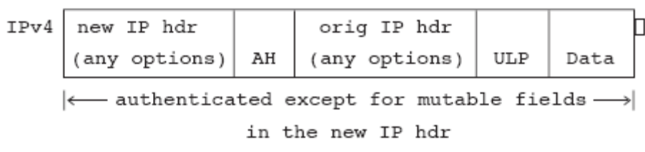

Fig: IP Packet after applying AH in Tunnel Mode
Encapsulating Security Payload
When ESP is used and confidentiality is selected in tunnel mode, the original IP header is well-protected because the entire original IP datagram is encrypted (see Figure). With an ESP authentication mechanism, the original IP datagram and the ESP header are included; however, the new IP header is not included in the authentication. This fact is important only for IPv6 because there are no known attacks that would require an IPv4 header to be authenticated. When both authentication and encryption are selected, encryption is performed first, before authentication. One reason for this order of processing is that it facilitates rapid detection and rejection of replayed or bogus packets by the receiving node. Prior to decrypting the packet, the receiver can detect the problem and potentially reduce the impact of denial-of-service attacks.
Fig: IP Packet after applying ESP in Tunnel Mode
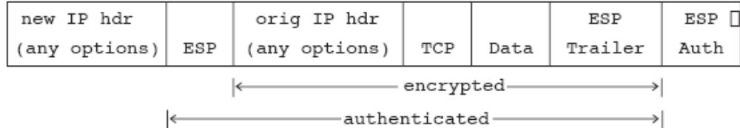
To summarize, when you want to make sure that certain data from a known and trusted source (authentication) gets transferred with integrity and does not need confidentiality, use the AH protocol. AH protects the upper-layer protocols and the IP header fields that do not change in transit, such as the source and destination addresses. AH cannot protect those fields that change in transit, such as the TTL field. Protection means that the values cannot be changed without detection, so the IPsec node will reject any altered IP datagram. To clarify, AH does not protect against someone sniffing the wire and seeing the headers and data. However, because headers and data cannot be changed without the change being detected, changed packets would get rejected.

If you need to keep data private (confidentiality), then you must use ESP. ESP will encrypt the upper-layer protocols in transport mode and the entire original IP datagram in tunnel mode so that neither are readable off the wire. ESP can also provide authentication for the packets. However, when using ESP in transport mode, the outer IP original header is not protected; in tunnel mode, the new IP header is not protected. Users will probably implement tunnel mode more than transport mode during initial IPsec usage. ESP can also be applied with the choice of the NULL encryption algorithm. When NULL is selected, no privacy is provided, thus it is recommended that an ESP authentication algorithm be used to afford integrity and authenticity to the data.

Security Associations
As mentioned in the overview, the establishment of SAs facilitates an IPsec-based conversation between two devices. Each device must agree on the policies or rules of their conversation by negotiating these policies with their potential peer.

IKE provides negotiation, peer authentication, key management, and key exchange. IKE negotiates a “contract” between the two IPsec endpoints. The SA is used to keep track of all the details of this negotiation for a single IPsec session. In fact, one of the main functions of IKE is to establish and maintain the SAs. The details that are tracked include:
- The mode of the authentication algorithm used in AH, and the keys to the authentication algorithm
- The mode of the encryption algorithm used in ESP, and the keys to the encryption algorithm
- The authentication algorithm, mode used in ESP, and the keys
- The SA lifetime (also the lifetime of the corresponding keys)
- The SA destination address
- The identities on whose behalf this SA is established
SAs should be viewed as the instantiation of security policy for a given data flow within the IKE/IPsec environment.

An SA is unidirectional, so it represents a simplex connection for the traffic. For example, when a bidirectional TCP session exists between two systems, A and B, there will be one SA from A to B and a separate SA from B to A. Two SAs (one in each direction) are required. The SA reflects the security services provided by the use of AH or ESP, but not both. If both AH and ESP are applied to a unidirectional traffic stream, then two SAs are created for the traffic stream.

An SA is uniquely identified by an IP destination address, a security protocol (AH or ESP) identifier, and a unique Security Parameter Index (SPI, pronounced spy) value. A SPI is a 32-bit number assigned to the initiator of the SA request by the receiving IPsec endpoint. The SPIs for AH and ESP are not the same for a given traffic flow (for example, IP|AH (500) |ESP (99999)|…). The SPI value is a field of both the AH and ESP headers. It is used to identify the appropriate SA in all the communications between the two end nodes. On receiving a packet, the destination address, protocol, and SPI are used to determine the SA, which allows the node to authenticate or decrypt the packet according to the security policy configured for that SA.

Below is a short piece of some debugging messages using both the debug crypto isakmp
And debug crypto ipsec commands. This short section of debug display was captured after IKE had been negotiated. The IKE and IPsec processes are creating two IPsec SAs, one in each direction. Notice the IP addresses for the two SAs. The source and destination addresses of the encryption endpoints are reversed on a bidirectional communication session.

Now the SAs have been created. To view the IPsec SAs that are active in the system, you use the show crypto ipsec sa command.
nrt#sh crypto ipsec sa
interface: Serial1/0
Crypto map tag: map1, local addr. 192.168.1.2
protected vrf:
local ident (addr/mask/prot/port): (10.0.0.0/255.0.0.0/0/0)
remote ident (addr/mask/prot/port): (20.0.0.0/255.0.0.0/0/0)
current_peer: 192.168.2.2:500
PERMIT, flags={origin_is_acl,}
#pkts encaps: 14, #pkts encrypt: 14, #pkts digest 0
#pkts decaps: 13, #pkts decrypt: 13, #pkts verify 0
#pkts compressed: 0, #pkts decompressed: 0
#pkts not compressed: 0, #pkts compr. failed: 0
#pkts not decompressed: 0, #pkts decompress failed: 0
#send errors 6, #recv errors 0

Key Management
Internet Key Exchange
IKE is the facilitator and manager of IPsec-based conversations. IKE is based on ISAKMP/Oakley, or the Internet Security Association Key Management Protocol/Oakley, which gives the reader a good understanding of the actual role of the protocols, establishment of security associations, and the management of keys. So IKE is a derivative of ISAKMP/Oakley specifically for IPsec.

IKE provides three modes for exchanging key information and setting up IKE SAs. The first two modes are phase 1 exchanges, which are used to set up the initial secure channel. The other mode is the phase 2 exchange, which negotiates IPsec SAs. The two modes in phase 1 are main mode and aggressive mode, and the phase 2 mode is called quick mode. The basic idea is to bootstrap an IKE SA to provide a protected pipe for subsequent protected IKE exchanges between the IKE peers, and then use phase 2 quick mode with the IKE SA to negotiate the IPsec SAs. Only IPsec uses the IPsec SA for protecting traffic.

Main mode has three two-way exchanges between the initiator and receiver. In the first exchange, the algorithms and hashes are agreed upon. The second exchange uses Diffie-Hellman to agree on a shared secret and to pass nonces (random numbers sent to the other party, signed and returned to prove their identity—they are signed only if encrypted nonces or digital signatures are being used). The third exchange verifies the identity of
the other side. In aggressive mode, fewer exchanges are done and with fewer packets. On the first exchange, almost everything is squeezed in—the proposed SA (algorithm, hashes, and mode), Diffie-Hellman public value, a nonce that the other party signs, and an ID packet, which can be used to verify identity via a third party. The receiver sends everything back that is needed to complete the exchange. The only thing left is for the initiator to confirm the exchange. The weakness of using the aggressive mode is that both sides have exchanged information before there is a secure channel. Therefore, it is possible to snoop the wire and discover who formed the new SA. However, aggressive mode is faster than main mode.

- Cisco IOS software automatically determines the correct phase 1 mode to use.
- Quick mode occurs after IKE has established the secure tunnel. Every packet is encrypted in quick mode.

Both negotiation of the IPsec SA and deriving the key material needed by IPsec are accomplished in quick mode. Before IKE will proceed, it is a requirement that the potential parties agree upon a way to authenticate themselves to each other. This authentication method is negotiated during the IKE phase 1 main mode exchange.

IKE Authentication
The IKE protocol is very flexible and supports multiple authentication methods as part of the phase 1 exchange. The two entities must agree on a common authentication protocol through a negotiation process. At this time, the following mechanisms are generally implemented:
- Preshared keys are the same keys preinstalled on each host. IKE peers authenticate each other by computing and sending a keyed hash of data that includes the preshared key. If the receiving peer is able to independently create the same hash using its preshared key, then it knows that both parties must share the same secret, thus authenticating the other party. Preshared keys are a nonpublic key option. As with manual keys, each peer shares a secret key, which has been exchanged out-of-band and configured into the router. Although, like manual keys, this scenario has some limitations for scaling, preshared keys scale better than manual IPsec keys and provide a more robust environment. First, it requires fewer keys to configure—one key per peer instead of two keys or more. Second, the preshared key is used in the phase 1 exchange, and the phase 2 derivation is still performed. This scenario adds to the scalability by allowing multiple streams between peers. Also, the ability of each side to demonstrate knowledge of this secret (without mentioning it) authenticates the exchange. Third, manual IPsec mode does not allow for rekeying of IPsec SAs between peers, although IKE does. Fourth, the keys derived are of better quality because the Diffie-Hellman key derivation is used. Finally, the actual work required at each peer makes it easier to implement.
- Public key cryptography requires that each party generate a pseudorandom number (a nonce) and encrypt it in the other party's public key. Authentication occurs when each party decrypts the other party's nonce with a local private key (and other publicly and privately available information) and then uses the decrypted nonce to compute a keyed hash. This system provides for deniable transactions. That is, either side of the exchange can plausibly deny that they took part in the exchange. Currently, only the RSA public key algorithm is supported.
- With the digital signature, each device digitally signs a set of data and sends it to the other party. This method is similar to the previous one, except that it provides non-repudiation. Currently both the RSA public key algorithm and the Digital Signature Standard (DSS) are supported.

The Importance of Certificates
Sharing keys does not scale to a large network. One method that does scale is encapsulation of the public key in a digital certificate authenticated by a Certificate Authority (CA). A CA is a trusted third party who can bind a public key to an identity. In this case, that includes the identity of devices, especially router and firewall devices. Within a CA domain, each device needs only its own certificate and the public key of the CA in order to authenticate every other device within the domain. The two encryption endpoints exchange these preexisting certificates that they have obtained from the CA.

The issuance of the certificate by the CA should be done at the time you install the device. It is not done for each IKE exchange. That is, after a device obtains a certificate, it does not need to contact the CA during the connection setup process. This setup avoids the reliability problems associated with a centralized key server.

The Cisco Certificate Enrollment Protocol (CEP) manages the certificate life-cycle process. This protocol supports operations such as certificate enrollment, certificate revocation, and certificate access allowing Cisco routers to participate within a public key infrastructure (PKI).

The general procedure is to first generate an RSA key pair on the router. The generated keys are saved in the private configuration in NVRAM. This private configuration is never displayed to the user or backed up to another device. A single CA must be defined for the router using its fully qualified Domain Name (FQDN) or IP address, the CA’s HTTP CGI script path, and optionally, the certificate revocation list (CRL) query URL. Second, the CA certificate must be retrieved. In order to authenticate the certificate of another device, the router must query the CA to obtain the CA certificate containing the CA public key. Because the router has no means of Introduction validating the CA certificate automatically, the key should be authenticated manually by contacting the CA
administrator and comparing the fingerprints of the certificate. The validated certificate is stored in the configuration, and the public key from the CA certificate is added to the RSA public key chain. Third, request that the CA generate a certificate for the key pair of the router by sending an enrollment request. A dialog is begun in which the user-defined certificate attributes are entered (a challenge password, a user addressable name, and optionally, the router serial number and IP addresses). The CA operator may cease to manually validate the request, and the fingerprints can be compared. The last step is receiving the certificate. Because there may be a significant delay, the certificate is retrieved asynchronously.

Note that there are situations in which IKE cannot establish policy and keys for IPsec. If there is no certificate defined in the router and there are only public key-based authentication methods in IKE policy, or if there is no certificate and no preshared keys for the peer (either shared directly by address or by a host name that has been configured with that address), IKE cannot negotiate with the peer and IPsec will not be able to work.

Configuration Overview
This section presents a sample IPsec and IKE configuration for the Cisco IOS software. The configuration will be broken down into major areas discussed as follows:
- Configuring IKE Security Associations
- Configuring IPsec Security Associations
- Configuring Crypto Maps
- Applying the Crypto Map and Triggering IPsec
- Configuring IPsec with Manual Keys

Configuring IKE Security Associations
Following is a sample configuration for setting up the IKE SA. The parameters for the SA are negotiated during IKE main mode. This example uses preshared keys as the authentication method. The actual shared key is shown in boldface type and must be the same on both peers.

crypto isakmp policy 10
hash md5
authentication pre-share
group 2
encryption 3des
crypto isakmp key cisco123 address 192.168.2.2

This defines the key as being shared with the peer based on the address of the peer. It is also possible to share a key based on the host name of a peer.

Configuring IPsec Security Associations
After IKE main mode has established the IKE SA, the peers will use quick mode to negotiate the parameters that form the basis of the IPsec SA. The following commands are an example of configuring these SA parameters; they include such parameters as determining the lifetime for which the SA will remain valid, the types of headers (AH, ESP, or AH and ESP) required, and the algorithms applied to the data exchanged between the peers.

crypto ipsec transform-set set1 esp-des esp-sha-hmac
mode transport

Configuring Crypto Maps
The IKE and IPsec SA parameters are brought together in a structure called a crypto map. This crypto map defines the peer to be contacted and the SA parameters to negotiate with that peer. The final piece of the crypto map is to define the traffic that will be used as the trigger mechanism for the IKE and IPsec SA establishment.
crypto map map1 10 ipsec-isakmp
set peer 192.168.2.2
set transform-set set1
match address 101
When this router receives traffic destined for a network that matches the rules defined in access list 101, it will initiate an IKE main mode exchange with the peer 192.168.2.2. It initiates IKE because of the ipsec-isakmp type of the crypto map. The peer 192.168.2.2 will choose the offer that matches the SA definitions configured for this device. If there is more than one match, the more secure offer will be chosen.

Applying the Crypto Map and Triggering IPsec
Two tasks remain before the router configuration is complete. The crypto map defined above must be applied to a router interface before it will be triggered.

interface Serial1/0
ip address 192.168.1.2 255.255.255.252
crypto map map1

As traffic is queued for outbound transit, it will be compared with the rules defined in access list 101 below. This list is referenced in the map1 crypto map via match address 101. If the traffic is a match, this will initiate IKE for the first packet in the flow to the peer device. Subsequent packets are processed as per the SA definitions until the expiration of an SA lifetime or the manual clearing of an SA. If the IPsec SA expires, IKE quick mode will be triggered and a new IPsec SA established. If the IKE SA expires, main mode will be re-executed, followed by quick mode.
access-list 101 permit ip 10.0.0.0 0.255.255.255 20.0.0.0 0.255.255.255

Configuring GRE Tunneling Over IPsec
!
interface Tunnel0
description GRE-Tunnel to HYD
ip address 1.1.1.1 255.0.0.0
tunnel source 192.168.1.2
tunnel destination 192.168.2.2
crypto map map1
!
Virtual LANs’
A major feature of Ethernet switching technology is called a VLAN, where switches are used to cluster workstations and servers into logical groupings. The devices in a VLAN are restricted to communicating with devices on their own VLAN so that the switched network operates like a number of unconnected individual LANs. It is often difficult to get an exact definition for a VLAN because vendors take varied approaches to creating VLANs.

Business often uses VLANs as a way of ensuring that a particular set of users is logically grouped. Compare this to a traditional workplace where departments were usually grouped in one “local” area; thus, a LAN was a natural development to meet the needs. Now people are not tied to physical spaces, so VLANs have developed “logical” areas. For example, people who work in the marketing section of the business are placed in the marketing VLAN, whereas people who work in the engineering section are placed in the engineering VLAN.

Benefits of VLANs
Companies are continuously reorganizing. On average, 20-40 percent of the workforce physically moves every year. These moves, additions, and changes are one of a network manager’s biggest headaches and one of the largest expenses related to managing the network. Many moves require recabling, and almost all moves require new station addressing and hub and router reconfigurations.

Change Management
VLANs provide an effective mechanism for controlling these changes and reducing much of the cost that is associated with hub and router reconfigurations. Users in a VLAN can share the same network address space (that is, the IP subnet), regardless of their locations. When users in a VLAN are moved from one location to another, as long as they remain within the same VLAN and are connected to a switch port, their network address does not change. A location change can be as simple as plugging a user into a port on a VLAN-capable switch and configuring the port on the switch to that VLAN. With dynamic VLANs, when the MAC address of the moved workstation’s network interface card is looked up on the VMPS, the switch automatically configures the port to be in the correct VLAN.

VLANs and Security
VLANS are an effective mechanism for extending firewalls from the routers to the switch fabric and protecting the network against potentially dangerous broadcast problems. In additions, VLANs maintain all the performance benefits of switching. You create firewalls by assigning switch ports or users to specific VLAN groups both within single switches and across multiple connected switches. Broadcast traffic within one VLAN is not transmitted outside the VLAN. The below figure shows an example of broadcast domains. Conversely, adjacent ports do not receive the broadcast traffic that other VLANs generate. This type of configuration substantially reduces the overall broadcast traffic, frees bandwidth for real user traffic, and lowers the overall vulnerability of network to broadcast storms.

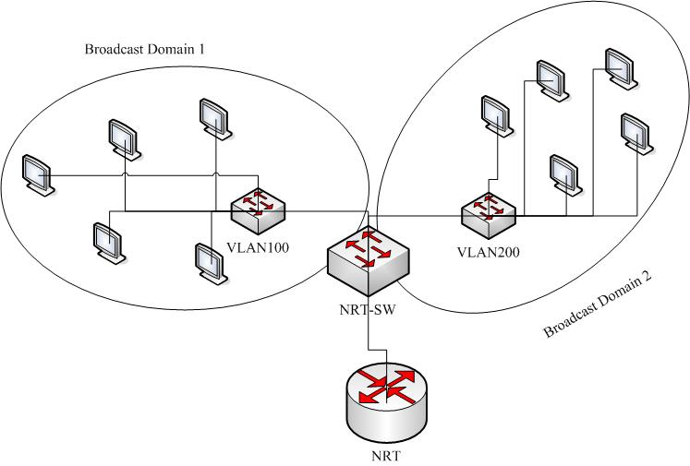

One problem of shared LANs is that they are relatively easy to penetrate. By plugging into a live port, an intrusive user ha access to all traffic that is within the segment. The large the group, the greater the potential access.

One cost-effective and easy administrative technique to increase security is to segment the network into multiple broadcast groups. This allows the network manager to do the following:
- Restrict the number of users in a VLAN group
- Prevent another user from joining without first receiving approval from the VLAN network management application
- Configure all unused ports to a default low-service VLAN

Implementing this type of segmentation is relatively straightforward. Switch ports are grouped together based on the type of applications and access privileges. Restricted applications and resources are commonly placed in a secured VLAN groups on the secured VLAN, the switch restricts access into the group. Restrictions can be placed based on station address, application types, or protocol types.
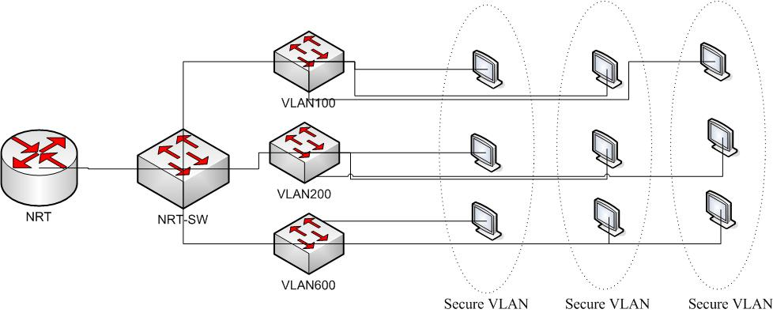

VLAN Frame Identification
With multi-switch VLANS, the frame headers are encapsulated or modified to reflect VLAN ID before the frame is sent onto the link between the switches. Before forwarding to the endpoint device, the frame header is changed back to the original format. VLAN identification logically identifies which packets belong to which VLAN group multiple trunking methodologies exist, including IEEE 802.1Q, ISL.

Inter-Switch Link Protocol
The Inter-Switch Link (ISL) protocol is a Cisco-proprietary method for preserving the source VLAN identification of frames passing over a trunk link. ISL performs frame identification in Layer 2 by encapsulating each frame between a header and a trailer. Any Cisco switch or router device configured for ISL can process and understand the ISL VLAN information. ISL primarily is used for Ethernet media, although Cisco has included provisions to carry Token Ring, FDDI, and ATM frames over Ethernet ISL. (A Frame-Type field in the ISL header indicates the source frame type.)

When a frame is destined out a trunk link to another switch or router, ISL adds a 26-byte header and a 4-byte trailer to the frame. The source VLAN is identified with a 15-bit VLAN ID field in the header. The trailer contains a cyclic redundancy check (CRC) value to ensure the data integrity of the new encapsulated frame. Figure 5-3 shows how Ethernet frames are encapsulated and forwarded out a trunk link. Because tagging information is added at the beginning and end of each frame, ISL sometimes is referred to as double tagging.

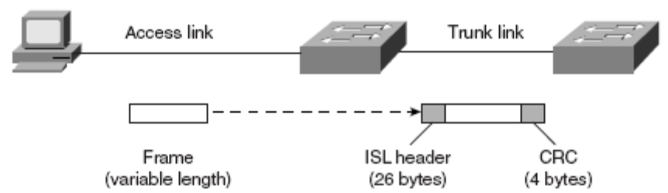

If a frame is destined for an access link, the ISL encapsulation (both header and trailer) is not rewritten into the frame before transmission. This removal preserves ISL information only for trunk links and devices that can understand the protocol.

IEEE 802.1Q Protocol
The IEEE 802.1Q protocol also can carry VLAN associations over trunk links. However, this frame-identification method is standardized, allowing VLAN trunks to exist and operate between equipment from multiple vendors.

In particular, the IEEE 802.1Q standard defines architecture for VLAN use, services provided with VLANs, and protocols and algorithms used to provide VLAN services.

As with Cisco ISL, IEEE 802.1Q can be used for VLAN identification with Ethernet trunks. However, instead of encapsulating each frame with a VLAN ID header and trailer, 802.1Q embeds its tagging information within the Layer 2 frame. This method is referred to as single tagging or internal tagging.

802.1Q also introduces the concept of a native VLAN on a trunk. Frames belonging to this VLAN are not encapsulated with any tagging information. If an end station is connected to an 802.1Q trunk link, the end station can receive and understand only the native VLAN frames. This provides a simple way to offer full trunk encapsulation to the devices that can understand it, while giving normal-access stations some inherent connectivity over the trunk.

In an Ethernet frame, 802.1Q adds a 4-byte tag just after the source address field, as shown in figure
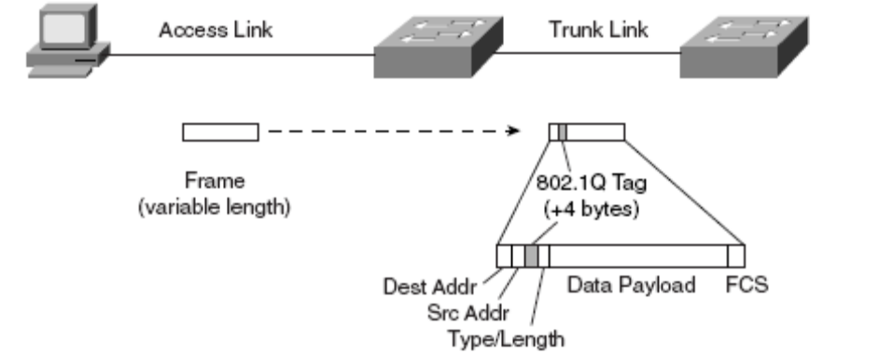
The first two bytes are used as a Tag Protocol Identifier (TPID) and always have a value of 0x8100 to signify an 802.1Q tag. The remaining two bytes are used as a Tag Control Information (TCI) field. The TCI information contains a three-bit Priority field, which is used to implement class-ofservice (CoS) functions in the accompanying 802.1Q/802.1p prioritization standard. One bit of the TCI is a Canonical Format Indicator (CFI), flagging whether the MAC addresses are in Ethernet or Token Ring format. (This also is known as canonical format, or little-endian or big-endian format.)

The last 12 bits are used as a VLAN Identifier (VID) to indicate the source VLAN for the frame. The VID can have values from 0 to 4095, but VLANs 0, 1, and 4095 are reserved.

Note that both ISL and 802.1Q tagging methods have one implication—they add to the length of an existing Ethernet frame. ISL adds a total of 30 bytes to each frame, whereas 802.1Q adds 4 bytes. Because Ethernet frames cannot exceed 1518 bytes, the additional VLAN tagging information can cause the frame to become too large. Frames that barely exceed the MTU size are called baby giant frames. Switches usually report these frames as Ethernet errors or oversize frames.

Implementation of VLAN
The implementation of VLAN is done global configuration mode. To select single port on a switch and enter fallowing commands in global configuration mode

interface FastEthernet0/0
switchport mode trunk
!
interface FastEthernet0/1
switchport access vlan 100
!
interface FastEthernet0/2
switchport access vlan 200
!
interface FastEthernet0/3
switchport access vlan 300
!
interface FastEthernet0/4
switchport access vlan 400
!
interface FastEthernet0/5
switchport access vlan 500
!
interface FastEthernet0/6
switchport access vlan 600
!
interface Vlan1
ip address 192.168.1.250 255.255.255.252
!
interface Vlan100
ip address 192.168.1.66 255.255.255.192
!
interface Vlan200
ip address 192.168.1.130 255.255.255.252
!
interface Vlan300
ip address 192.168.1.195 255.255.255.224
!
interface Vlan400
ip address 192.168.1.226 255.255.255.248
!
interface Vlan500
ip address 192.168.1.234 255.255.255.248
!
interface Vlan600
ip address 192.168.1.242 255.255.255.248
!

Implementing Inter VLAN Routing
When a host in one broadcast domain wants to communicate with a host in another broadcast domain, a router must be involved. The same situation exists with VLANs.

The most important benefit of routing is its proven history of facilitating networks, particularly networks that are large. Although the Internet serves as the obvious example, this point is true for any type of network, such as a large campus backbone. Because routers prevent broadcast propagation and use more intelligent forwarding algorithm than bridges and switches, routers provide much more efficient use of bandwidth. This simultaneously results in flexible and optimal path selection. For example, it is easy to implement load balancing across multiple paths in most networks when you are using routing On the other Layer2 load balancing can be difficult to design implement and main.
Configuration Inter-VLAN Routing
interface FastEthernet0/0.1
encapsulation dot1Q 1 native
ip address 192.168.1.249 255.255.255.252
!
interface FastEthernet0/0.100
encapsulation dot1Q 100
ip address 192.168.1.65 255.255.255.192
!
interface FastEthernet0/0.200
encapsulation dot1Q 200
ip address 192.168.1.129 255.255.255.192
!
interface FastEthernet0/0.300
encapsulation dot1Q 300
ip address 192.168.1.194 255.255.255.224
!
interface FastEthernet0/0.400
encapsulation dot1Q 400
ip address 192.168.1.225 255.255.255.248
!
interface FastEthernet0/0.500
encapsulation dot1Q 500
ip address 192.168.1.233 255.255.255.248
!
interface FastEthernet0/0.500
encapsulation dot1Q 500
ip address 192.168.1.241 255.255.255.248

Router Passwords
To configure router passwords we need fallow certain conditions
- Every router needs a locally configured router for privilege access
- Different ways to gain administrative access to the router are:
  - Console port
  - Telnet
  - Secure Shell
  - Enhanced username and passwords
- Passwords can be 1 to 25 characters in length.
- Passwords can include alphanumeric characters, uppercase and lowercase characters, symbols and spaces
- Passwords cannot have a number as the first character.
- Password-leading spaces are ignored, but all spaces after the first character are not ignored.
- Best practice is to frequently change the passwords

Console Port Passwords
Console Passwords are implemented in global configuration mode
nrt (config) #line console 0
nrt (config-line) #password nara
Telent Port Passwords
vty password is for logging via telnet, the telnet password are enable in global configuration mode
nrt (config)#line vty 0 4
nrt (config-line)#password vishnu
Enable password
The password are used to enter the enable mode or privilege exec mode, this passwords area encrypted by using one-way hash based on md5
nrt (config) #enable password vishnu
or
nrt (config) #enable secret vishnu
Enhanced username and passwords
The enhanced username and passwords are configured in the global configuration mode
nrt (config) # username malli privilege 0 secret malli
nrt (config)# username raghava privilege 15 secret raghava
when ever the user access to via telnet to the router he asks password and username when he enter username malli and password malli he enter usermode, the privilege level 0 is for usermode and privilege 15 is for enable mode or privileged exec mode

SSH
Telnet was developed in an era when security was not an issue. The network administrator should recognize that the data within a telnet session is sent as plaintext and may be intercepted by anyone with a packet Sniffer located along the data path between the managed device and the management server. The clear text may include important or sensitive information, such as the configuration of the device itself, passwords, or other sensitive data.
Configuring SSH
To configure SSH before we have to follow some conditions
- Ensure that the target routers are running a Cisco IOS software Release 12.1(1)T image or later with the IPsec feature set. Only Cisco IOS software images contain the IPsec feature set support an SSH server.
- Ensure that the target routers are configured for local authentication, AAA server for username/password authentication, or both.
- Ensure that each of the target routers has a unique hostname.
- Ensure that each of the target routers is using the correct domain name of your network.
To complete the configuration SSH server
- Configure the IP domain name of your network using the ip domain-name command in global configuration mode:
  - nrt(config)#ip domain-name nrt.com
- Generate keys to used with SSH by generating the RSA keys using the crypto key generate rsa command in global configuration mode:
  - nrt(config)# crypto key generate rsa general-keys modulus 1024
- optionally, to display the generated keys, use the show crypto key mypubkey rsa command in privileged EXEC mode
- Configure the time that the router waits for the SSH client to respond using the ip ssh timeout command in global configuration mode:
  - nrt(config)# ip ssh timeout 60
- Configure the SSH retries using the ip ssh authentification-retries command in global configuration mode:
  - nrt(configt)# ip ssh authentication-retries 4
- enable vty inbound ssh sessions;
  - nrt(config)# transport input ssh

The SSH protocol is automatically enabled once you generate the SSH (RSA) keys. Once the keys are created, you may access the router SSH server using your SSH client software or using fallowing command in privileged mode
nrt# ssh –l malli 192.168.1.1
Here malli is user name on 192.168.1.1 router, by entering above it asks the password.

The procedure for connecting to a Cisco router SSH server varies depending on the SSH client application that you are suing. Generally the SSH clients passes your username to the router SSH server. The router SSH server prompts you for the correct password. Once the password has been verified, you can configure and manage the router as if you were a standard vty user.
IP Subnet Calculator
The IP subnet calculator is for avoid over heads to administrator in calculating IP subnets, By using this we can effectively subnet the whole IP address.
The fallowing features have IP Subnet Calculator
- It gives the network address.
- It gives the broadcast address.
- It gives the valid hosts range.
- It gives the number of hosts.
- It gives the number subnets.
- It gives number of host bits.
- It gives number of subneted bits.
- It gives default and required subnet mask.
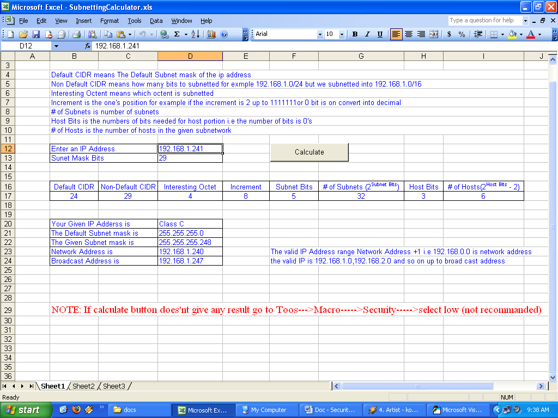
Screenshot for IP Subnet Calculator

Screen shots

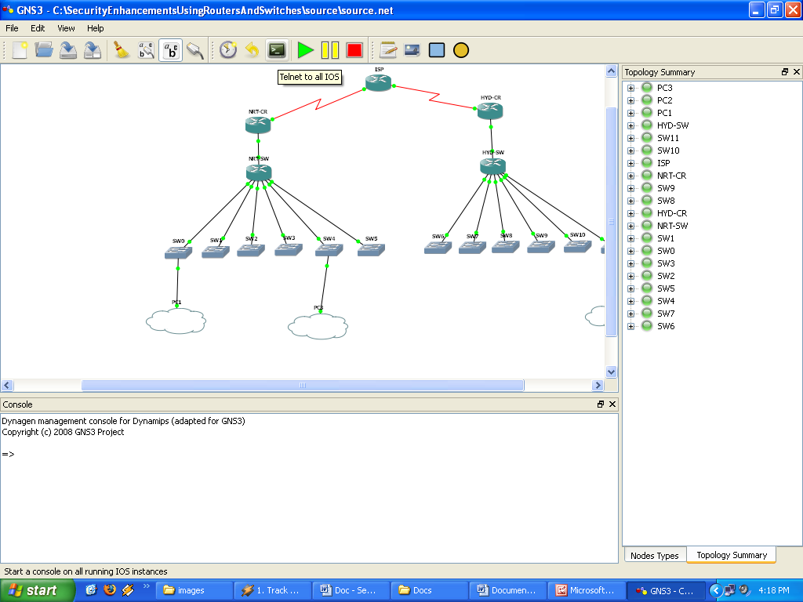
Fig: Starting all Routers and switches
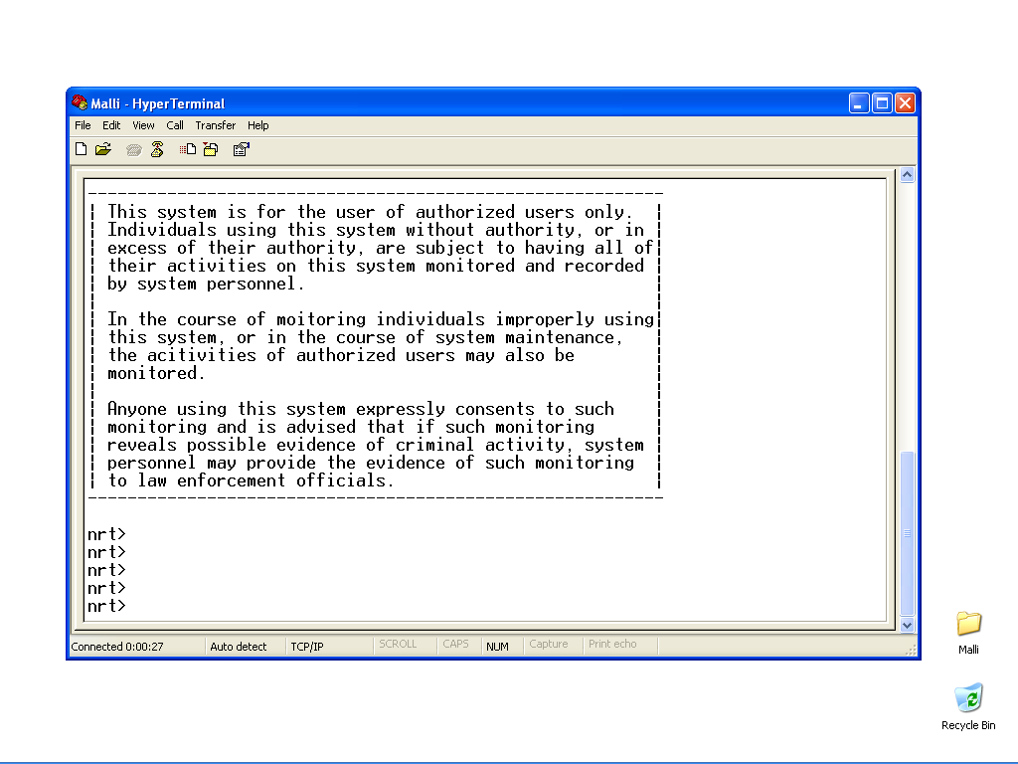
Fig: When log into the Router the Security banner will display
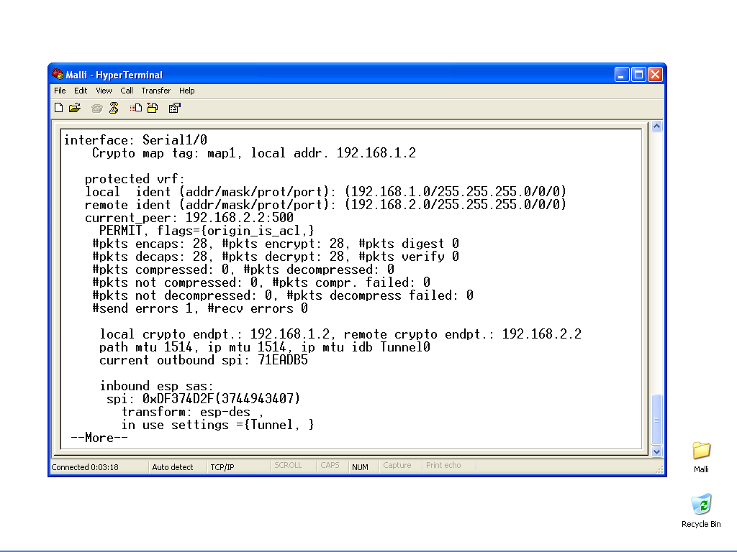
Fig: The Security Association of IPsec
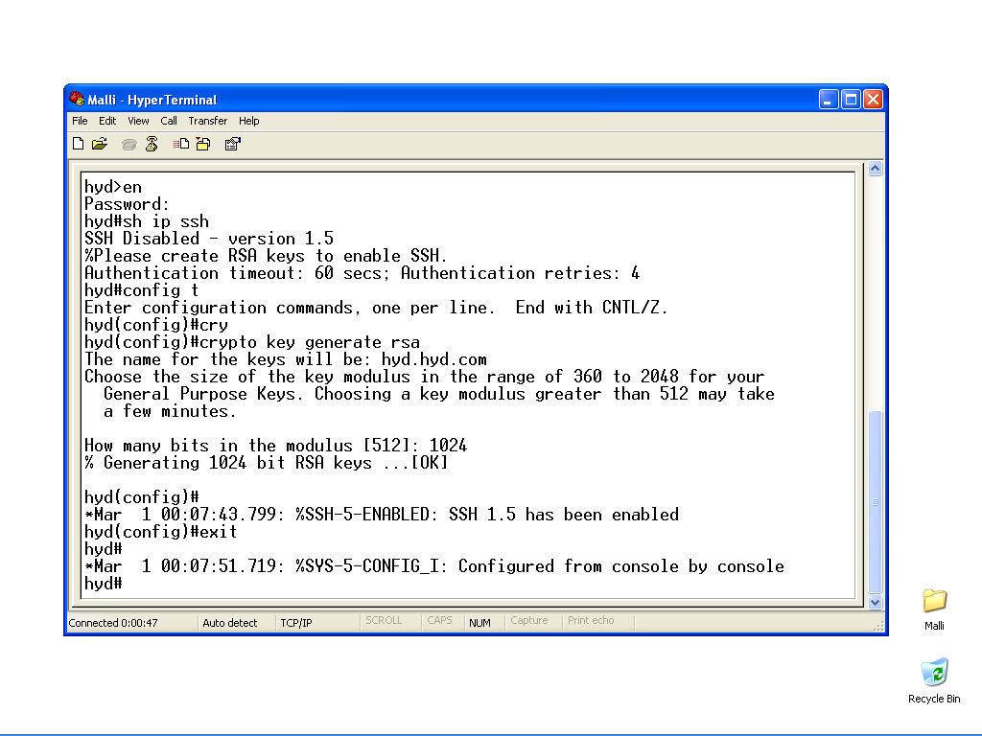
Fig: SSH configuration and login
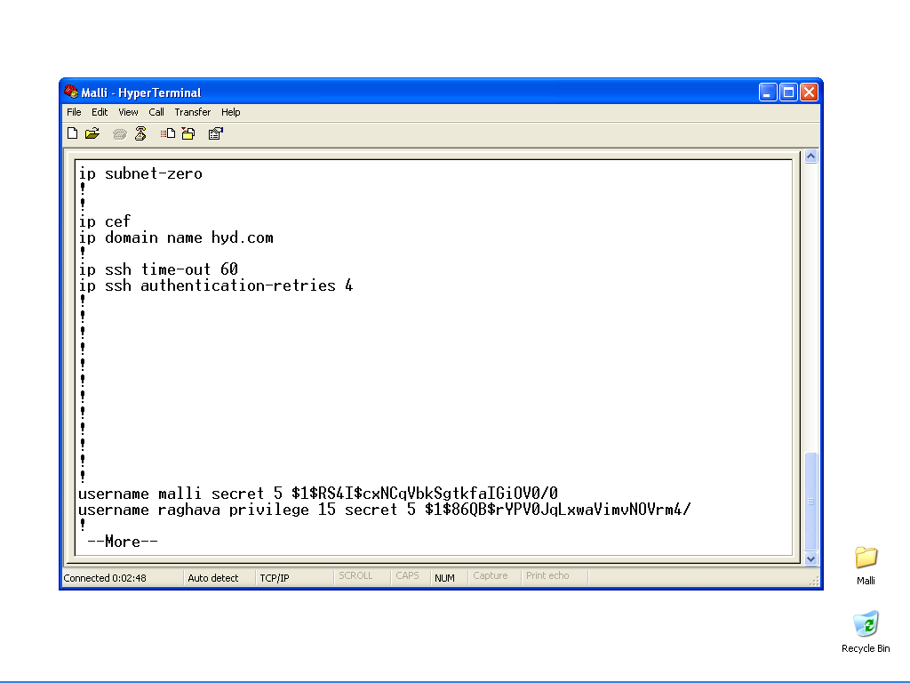
Fig: The Routers passwords with secret key
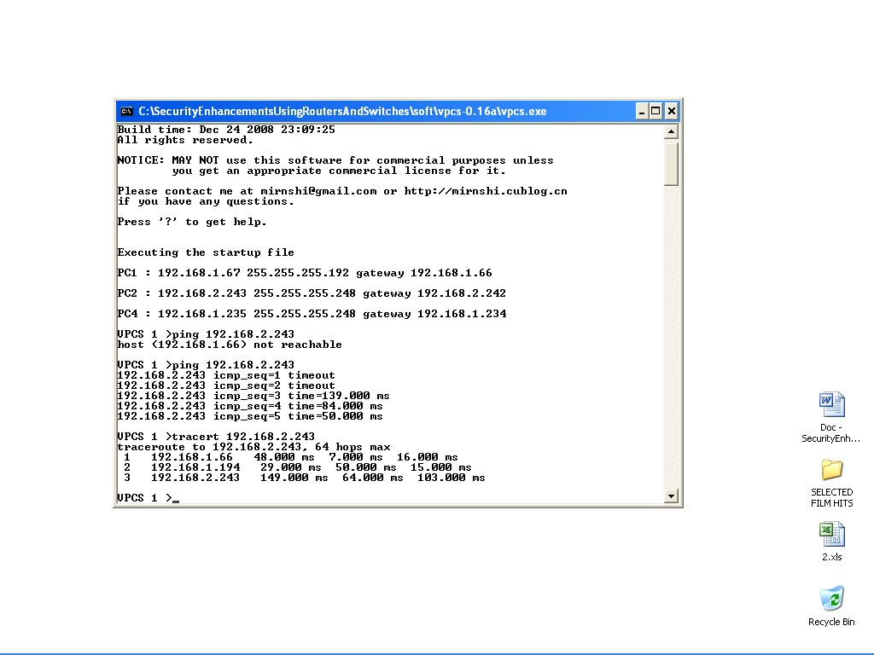
Fig: Testing connectivity with VPC

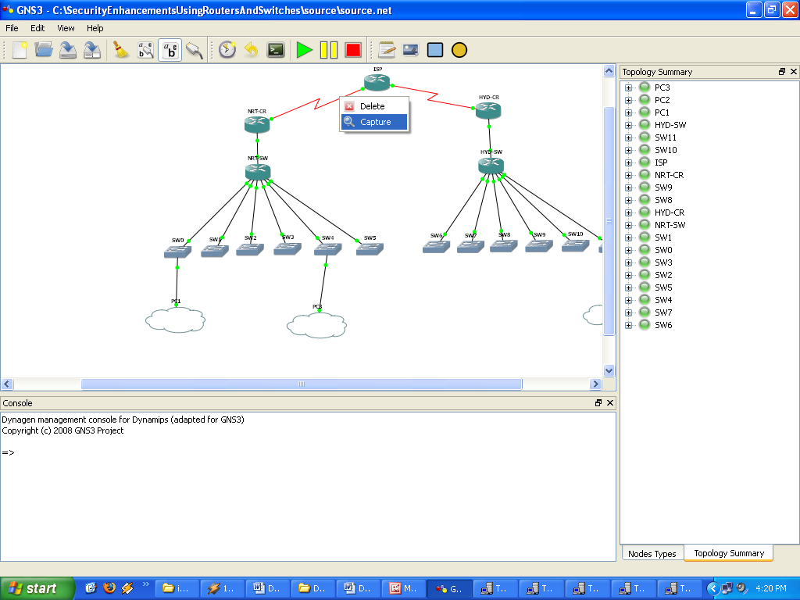
Fig: How to capture the packets in a network
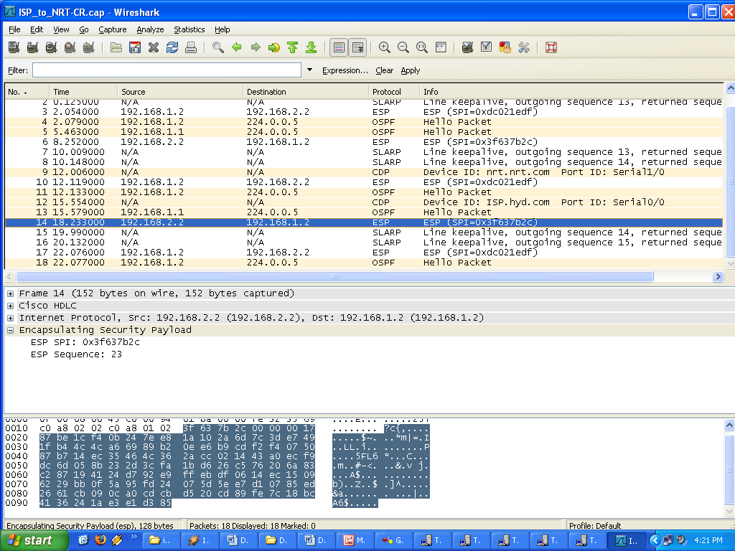
Fig: Between site-site to packet encryption is done

Testing
Test C. ID. | Input | Expected Behavior | Observed Behavior | Status  P = Pass  F = Fail
1. | Console login password wrong | Login restricted | -do- | P
2. | Telnet login password wrong | Login restricted | -do- | P
3. | SSH login password wrong | Login restricted | -do- | P
4. | Number of retries exceeds to SSH login | Login restricted | -do | P
5. | The encapsulation methods are different | Packets are dropped | -do- | P
6. | Trigger Updates | When the topology changes the info updated | -do- | P
7. | Data Confidentiality | Encrypt the packets | -do- | P
8. | Data Integrity | Ensure the packet authenticate | -do- | P
9. | Data Origin Authentication | IPSec authenticate the source IP address | -do- | P
10. | Anti-reply | Verifies each packet is unique | -do- | P
In Testing I perform different testing cases, on the routers and switches are in my network topology. The results of the test cases are listed in the table.

Scope for Future Enhancements
This kind of project is "infinite," so below listed some ideas for future implementations. As any open source project, it would be very nice if you wish to contribute.
- In future add any number of branches to my project.
- In future the routers are configured by GUI.
- Further implement redistribution in the network.
- In future replace with higher end series routers/switches with old one.
- Put a firewall device in future.
- Put alarms when ever security violations are occurred.

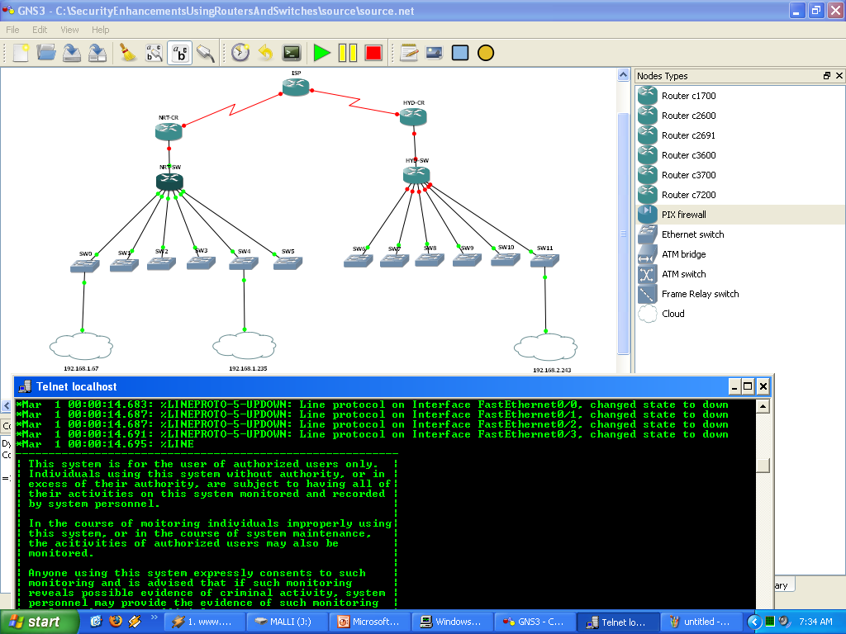
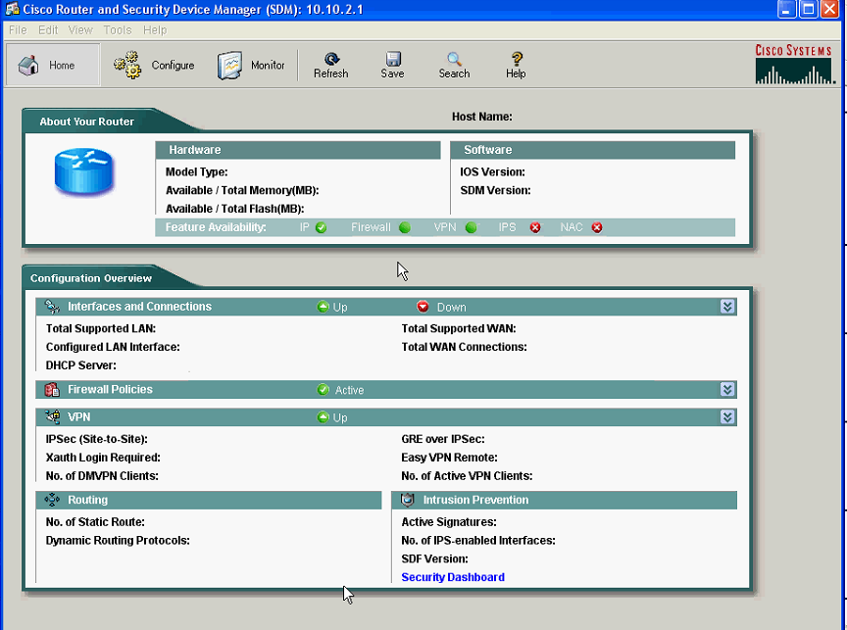
References
- Cisco Certified Network Associate – Sybex 6th edition.
- Cisco Networking Academy Program CCNA® 1 and 2 Companion guide – Pearson Edition Revised 3rd edition.
- Cisco Networking Academy Program CCNA® 3 and 4 Companion guide – Pearson Edition 3rd edition.
- CCNP BSCI Official Exam Certification Guide – Pearson Edition 4th edition.
- CCNP BCMSN Official Exam Certification Guide – Pearson Edition 4th edition.
- CCNP ISCW Official Exam Certification Guide – Pearson Edition 4th edition.
- Cisco – IPsec Virtual Private Network Fundamentals (2006) James Henry Carmouche, CCIE NO.6085.
- http://www.gns3.net/
- http://www.google.com
- http://www.youtube.com

